DAY-3
1.Stack operations using array such as PUSH, POP and PEEK.
#include <stdio.h>
#define MAX_SIZE 10
int top = -1;
int stack[MAX_SIZE];
int isEmpty() {
return top == -1;
}
int isFull() {
return top == MAX_SIZE - 1;
}
void push(int element) {
if (isFull()) {
printf("Stack is full. Cannot push %d.\n", element);
return;
}
stack[++top] = element;
printf("Pushed %d onto the stack.\n", element);
}
int pop() {
if (isEmpty()) {
printf("Stack is empty. Cannot pop.\n");
return -1;
}
return stack[top--];
}
int peek() {
if (isEmpty()) {
printf("Stack is empty. Cannot peek.\n");
return -1;
}
return stack[top];
}
void displayStack() {
printf("Stack: ");
for (int i = 0; i <= top; i++) {
printf("%d ", stack[i]);
}
printf("\n");
}
int main() {
push(10);
push(20);
push(30);
displayStack();
printf("Popped: %d\n", pop());
displayStack();
printf("Peek: %d\n", peek());
displayStack();
push(40);
push(50);
displayStack();
printf("Popped: %d\n", pop());
displayStack();
return 0;
}
OUTPUT:
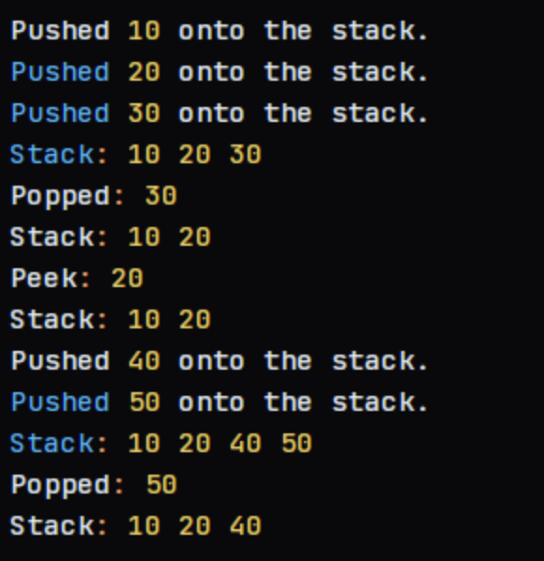
2. Stack operations using linked list such as PUSH, POP and PEEK.
#include <stdio.h>
#include <stdlib.h>
typedef struct Node {
int data;
struct Node* next;
} Node;
typedef struct Stack {
Node* top;
} Stack;
Node* createNode(int data) {
Node* newNode = (Node*)malloc(sizeof(Node));
newNode->data = data;
newNode->next = NULL;
return newNode;
}
Stack* createStack() {
Stack* stack = (Stack*)malloc(sizeof(Stack));
stack->top = NULL;
return stack;
}
void push(Stack* stack, int data) {
Node* newNode = createNode(data);
newNode->next = stack->top;
stack->top = newNode;
printf("Pushed %d onto the stack.\n", data);
}
int pop(Stack* stack) {
if (stack->top == NULL) {
printf("Stack is empty. Cannot pop.\n");
return -1;
}
int data = stack->top->data;
Node* temp = stack->top;
stack->top = stack->top->next;
free(temp);
return data;
}
int peek(Stack* stack) {
if (stack->top == NULL) {
printf("Stack is empty. Cannot peek.\n");
return -1;
}
return stack->top->data;
}
void displayStack(Stack* stack) {
Node* temp = stack->top;
printf("Stack: ");
while (temp != NULL) {
printf("%d ", temp->data);
temp = temp->next;
}
printf("\n");
}
int main() {
Stack* stack = createStack();
push(stack, 10);
push(stack, 20);
push(stack, 30);
displayStack(stack);
printf("Popped: %d\n", pop(stack));
displayStack(stack);
printf("Peek: %d\n", peek(stack));
displayStack(stack);
push(stack, 40);
push(stack, 50);
displayStack(stack);
printf("Popped: %d\n", pop(stack));
displayStack(stack);
return 0;
}
OUTPUT:
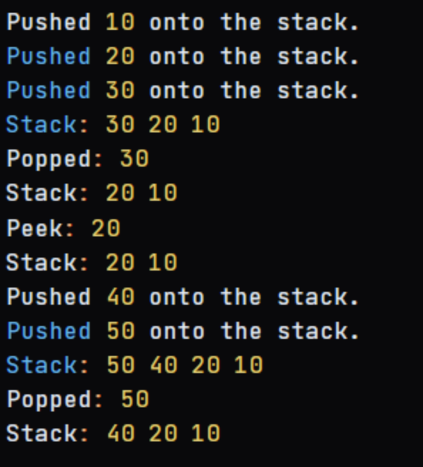
3. Sorting elements using a stack (e.g., sorting a stack using recursion).
#include <stdio.h>
#include <stdlib.h>
typedef struct Node {
int data;
struct Node* next;
} Node;
typedef struct Stack {
Node* top;
} Stack;
Node* createNode(int data) {
Node* newNode = (Node*)malloc(sizeof(Node));
newNode->data = data;
newNode->next = NULL;
return newNode;
}
Stack* createStack() {
Stack* stack = (Stack*)malloc(sizeof(Stack));
stack->top = NULL;
return stack;
}
void push(Stack* stack, int data) {
Node* newNode = createNode(data);
newNode->next = stack->top;
stack->top = newNode;
}
int pop(Stack* stack) {
if (stack->top == NULL) {
printf("Stack is empty. Cannot pop.\n");
return -1;
}
int data = stack->top->data;
Node* temp = stack->top;
stack->top = stack->top->next;
free(temp);
return data;
}
void sortStack(Stack* stack) {
if (stack->top == NULL) return;
int temp = pop(stack);
sortStack(stack);
sortedInsert(stack, temp);
}
void sortedInsert(Stack* stack, int data) {
if (stack->top == NULL || data > stack->top->data) {
push(stack, data);
} else {
int temp = pop(stack);
sortedInsert(stack, data);
push(stack, temp);
}
}
void displayStack(Stack* stack) {
Node* temp = stack->top;
printf("Stack: ");
while (temp != NULL) {
printf("%d ", temp->data);
temp = temp->next;
}
printf("\n");
}
int main() {
Stack* stack = createStack();
push(stack, 5);
push(stack, 2);
push(stack, 8);
push(stack, 3);
push(stack, 1);
push(stack, 6);
push(stack, 4);
printf("Original Stack: ");
displayStack(stack);
sortStack(stack);
printf("Sorted Stack: ");
displayStack(stack);
return 0;
}
OUTPUT:
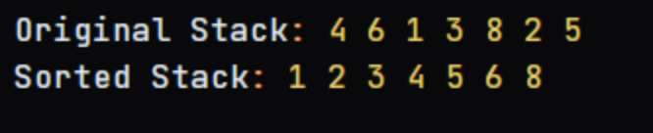
4.Simulate Recursive Function Calls Using a Stack
#include <stdio.h>
#include <stdlib.h>
typedef struct Node {
int data;
struct Node* next;
} Node;
typedef struct Stack {
Node* top;
} Stack;
Node* createNode(int data) {
Node* newNode = (Node*)malloc(sizeof(Node));
newNode->data = data;
newNode->next = NULL;
return newNode;
}
Stack* createStack() {
Stack* stack = (Stack*)malloc(sizeof(Stack));
stack->top = NULL;
return stack;
}
void push(Stack* stack, int data) {
Node* newNode = createNode(data);
newNode->next = stack->top;
stack->top = newNode;
}
int pop(Stack* stack) {
if (stack->top == NULL) {
printf("Stack is empty. Cannot pop.\n");
return -1;
}
int data = stack->top->data;
Node* temp = stack->top;
stack->top = stack->top->next;
free(temp);
return data;
}
void simulateRecursiveCalls(Stack* stack, int n) {
if (n <= 0) return;
push(stack, n);
simulateRecursiveCalls(stack, n-1);
int data = pop(stack);
printf("Data: %d\n", data);
}
int main() {
Stack* stack = createStack();
simulateRecursiveCalls(stack, 5);
return 0;
}
OUTPUT:
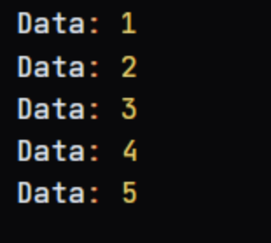
5.Implement undo and redo functionality using two stacks.
#include <stdio.h>
#include <stdlib.h>
typedef struct Node {
int data;
struct Node* next;
} Node;
typedef struct Stack {
Node* top;
} Stack;
Node* createNode(int data) {
Node* newNode = (Node*)malloc(sizeof(Node));
newNode->data = data;
newNode->next = NULL;
return newNode;
}
Stack* createStack() {
Stack* stack = (Stack*)malloc(sizeof(Stack));
stack->top = NULL;
return stack;
}
void push(Stack* stack, int data) {
Node* newNode = createNode(data);
newNode->next = stack->top;
stack->top = newNode;
}
int pop(Stack* stack) {
if (stack->top == NULL) {
printf("Stack is empty. Cannot pop.\n");
return -1;
}
int data = stack->top->data;
Node* temp = stack->top;
stack->top = stack->top->next;
free(temp);
return data;
}
void displayStack(Stack* stack) {
Node* temp = stack->top;
printf("Stack: ");
while (temp != NULL) {
printf("%d ", temp->data);
temp = temp->next;
}
printf("\n");
}
int main() {
Stack* undoStack = createStack();
Stack* redoStack = createStack();
int choice, data;
while (1) {
printf("1. Push\n");
printf("2. Pop\n");
printf("3. Undo\n");
printf("4. Redo\n");
printf("5. Exit\n");
printf("Enter your choice: ");
scanf("%d", &choice);
switch (choice) {
case 1:
printf("Enter data to push: ");
scanf("%d", &data);
push(undoStack, data);
printf("Undo Stack: ");
displayStack(undoStack);
break;
case 2:
return 0;
default:
printf("Invalid choice. Please try again.\n");
}
}
return 0;
}
OUTPUT:
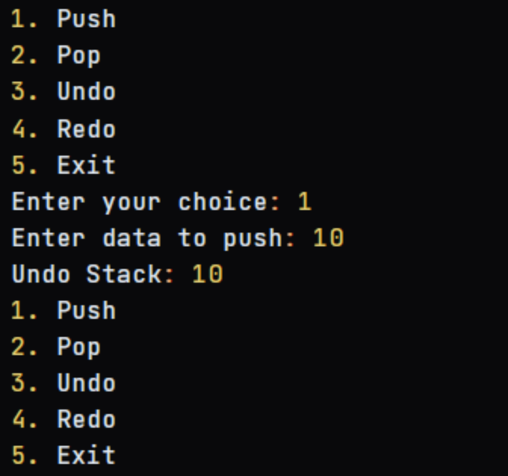
6.Check if a string is a palindrome using a stack.
#include <stdio.h>
#include <stdlib.h>
#include <string.h>
typedef struct Node {
char data;
struct Node* next;
} Node;
typedef struct Stack {
Node* top;
} Stack;
Node* createNode(char data) {
Node* newNode = (Node*)malloc(sizeof(Node));
newNode->data = data;
newNode->next = NULL;
return newNode;
}
Stack* createStack() {
Stack* stack = (Stack*)malloc(sizeof(Stack));
stack->top = NULL;
return stack;
}
void push(Stack* stack, char data) {
Node* newNode = createNode(data);
newNode->next = stack->top;
stack->top = newNode;
}
char pop(Stack* stack) {
if (stack->top == NULL) {
printf("Stack is empty. Cannot pop.\n");
return '\0';
}
char data = stack->top->data;
Node* temp = stack->top;
stack->top = stack->top->next;
free(temp);
return data;
}
int isPalindrome(char* str) {
int len = strlen(str);
Stack* stack = createStack();
for (int i = 0; i < len / 2; i++) {
push(stack, str[i]);
}
int start = len % 2 == 0 ? len / 2 : len / 2 + 1;
for (int i = start; i < len; i++) {
char top = pop(stack);
if (top != str[i]) {
return 0;
}
}
return 1;
}
int main() {
char str[100];
printf("Enter a string: ");
scanf("%s", str);
if (isPalindrome(str)) {
printf("%s is a palindrome.\n", str);
} else {
printf("%s is not a palindrome.\n", str);
}
return 0;
}
OUTPUT:
